SIMATS ENGINEERING
DEPARTMENT OF INFORMATION TECHNOLOGY
DSA03 – NATURAL LANGUAGE PROCESSING
ASSIGNMENT – 3 (CO3)
DESIGN, PARSE AND PROBABILISTICALLY RANK ENGLISH QUERIES
FOR A UNIVERSITY HELPDESK
STUDENT DETAILS
Name | A. Reddy Prasad
Register Number | 192472045
Programme / Section | CSE – AI
Year | 3rd Year
Faculty | Dr. M. Ramkumar
Course Code | DSA03
Course Title | Natural Language Processing
CO Coverage | CO3
Total Marks | 50
Duration | 1 Week
Submission Date | 17-11-2026.

ASSIGNMENT EVALUATION / MARK SHEET
Task | Description | Marks | Awarded
1 | Context-Free Grammar for English Syntax | 5
2 | Derivations and Parse Trees | 3
3 | Sentence-Level Constructions | 4
4 | Agreement | 3
5 | Subcategorization | 4
6 | Top-Down Parsing | 4
7 | Earley Parsing | 5
8 | Feature Structures and Unification | 4
9 | Probabilistic CFG | 5
10 | Implement and Test Parsers | 3
11 | Compare and Recommend | 2
12 | Day-4 Design Challenge | 8
 | TOTAL | 50

Evaluator Comments: __________________________________________________________
Faculty Signature: __________________________ Date: __________________
Student Declaration: This assignment is prepared for academic learning. Illustrative calculations are identified and must be replaced with actual measured results wherever required.

INTRODUCTION AND DESIGN OVERVIEW
This assignment designs a grammar-based syntactic analyser for a university helpdesk assistant handling queries about timetables, examinations, hostels, fees, library services and placements. The solution uses a Context-Free Grammar (CFG), agreement and subcategorization constraints, top-down and Earley parsing, feature structures and a Probabilistic CFG (PCFG) to rank ambiguous parses.

Problem Statement
Before extracting meaning, each query must be assigned a reliable syntactic structure. A controlled grammar is interpretable but may not cover conversational or noisy messages. The design combines explicit linguistic rules with probabilistic ranking and a partial-parse fallback.

Design assumptions and evidence note
- The grammar is a proposed controlled English fragment, not a complete grammar of English.
- The supplied PDF contains assignment requirements but no annotated corpus or measured parser logs. Example probabilities and traces are instructional examples, not experimental findings.
- The brief requires at least 30 query sentences, a lexicon of at least 60 words and a mini-treebank of at least 20 parsed sentences. Execute the implementation and record actual results before submission.
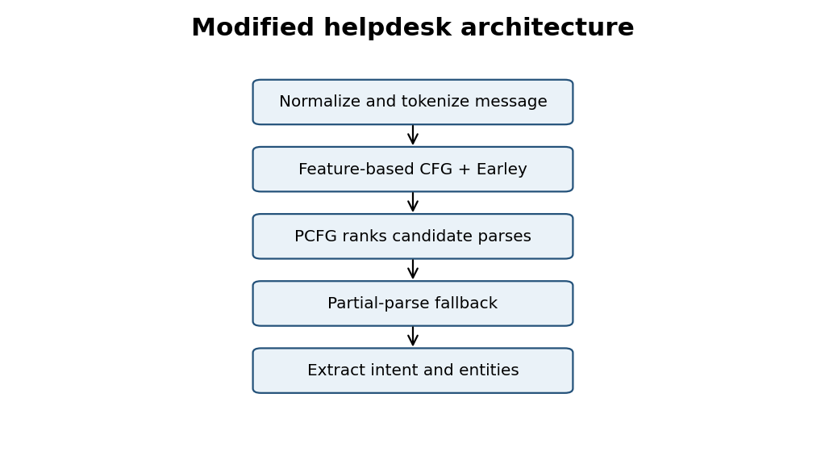
Figure 1. Overall proposed helpdesk parsing workflow.

TASK 1 – Design a Context-Free Grammar for English Syntax (5 Marks)
Guiding Enquiry: How can English phrase structure be captured by a finite set of context-free rules while keeping the grammar expressive and manageable?
Investigate and interpret
A Context-Free Grammar is G = (N, Σ, R, S): N is the set of non-terminals, Σ the terminal vocabulary, R the production rules and S the start symbol. Each production has one non-terminal on its left side.

1.1 Grammar components
Component | Definition / example
N | S, DECL, IMP, YNQ, WHQ, NP, VP, PP, AdjP, AdvP, CP, Det, N, V, Aux, Conj
Σ | Helpdesk words such as student, timetable, exam, hostel, fee, library, submit, check, book, receipt
R | Phrase-structure productions listed below
S | Start symbol for a complete utterance

1.2 CFG production rules
S -> DECL | IMP | YNQ | WHQ
DECL -> NP VP
IMP -> VP
YNQ -> Aux NP VP
WHQ -> WH VP | WH Aux NP VP
NP -> Pron | ProperN | Det N | Det AdjP N
NP -> NP PP | NP RelClause | NP Conj NP
VP -> V_INTR | V_TRANS NP | V_DITRANS NP NP
VP -> V_PP PP | V_SCOMP CP | V_NP_SCOMP NP CP
VP -> Aux VP | Modal VP | VP AdvP | VP PP | VP Conj VP
PP -> P NP
AdjP -> Adj | Adv Adj
AdvP -> Adv | Adv AdvP
CP -> Comp S
RelClause -> RelPron VP | RelPron NP VP
DECL -> NP Aux VP

The rules are context-free because each left-hand side contains exactly one non-terminal. Recursive rules such as NP → NP PP permit noun phrases with multiple modifiers and therefore generate unbounded structures from a finite rule set.

1.3 Lexicon (60+ terminals)
Category | Words
Determiners | the, a, an, this, these, those, my, your, each, every
People nouns | student, students, faculty, teacher, staff, applicant, librarian, officer
Domain nouns | timetable, exam, examination, hostel, room, library, book, portal, placement, form, fee, receipt, notice, result, course
Place/time nouns | today, tomorrow, Monday, semester, campus, department, counter, office, laboratory, hall
Verbs | check, checks, submit, submits, show, shows, book, books, send, sends, tell, tells, apply, applies, pay, pays, need, needs, arrive, crashed, postponed, held
Auxiliaries/modals | do, does, did, is, are, was, were, can, could, will, would, should, may
Pronouns | I, we, you, he, she, they, it, me, us, him, her, them
Adj/Adv | late, available, current, new, required, online, urgently, quickly, recently
Prepositions/conjunctions | to, for, with, near, in, on, at, from, by, and, or, that, whether, when, who

1.4 Constituency tests
Sentence | Test | Interpretation
The students submitted the form. | Substitution: “The students” → “They”; “the form” → “it”. | Both are noun phrases.
The student near the library checked the timetable. | Movement: “Near the library, the student checked the timetable.” | “Near the library” is a PP constituent.
The clerk checked the form and the timetable. | Coordination of “the form” and “the timetable”. | Both are NPs.

The head determines the phrase category: a noun heads NP, a verb heads VP and a preposition heads PP. A simple CFG struggles with agreement and some long-distance dependencies; feature structures are introduced in Task 8 to handle local feature constraints compactly.
Evidence Expected: A formal CFG, more than 40 phrase-structure rules, a 60+ word domain lexicon and constituency tests.

TASK 1 – Additional Explanation

1.5 Recursive structure and CFG limitation
For example, NP → NP PP allows “the student near the library in the main building”. The recursion can continue with further PPs. The grammar remains finite because recursion reuses the same production. A context-free rule cannot directly compare arbitrary distant words for matching agreement without adding feature mechanisms or multiplying categories.

1.6 Example derivation shape
S
└── DECL
├── NP
│ ├── Det: The
│ └── N: student
└── VP
├── V: checks
└── NP
├── Det: the
└── N: timetable

This tree shows the hierarchical relationship between the subject NP and predicate VP. The verb “checks” is the VP head, while “student” is the head of the subject NP. The constituent tests above support these groupings.
A practical grammar should separate the rule system from the lexicon. New helpdesk vocabulary can then be added without rewriting phrase-structure rules.

TASK 2 – Context-Free Rules, Derivations and Parse Trees (3 Marks)
Guiding Enquiry: How are sentences generated from the grammar, and how do trees represent and compare syntactic analyses?
Investigate and interpret
A derivation is a sequence of rule applications that expands S into terminals. A parse tree records the hierarchy of those applications. A leftmost derivation expands the leftmost non-terminal first; a rightmost derivation expands the rightmost non-terminal first.

2.1 Worked derivation: The student checks the timetable.
Leftmost:
S => DECL => NP VP => Det N VP
=> The N VP => The student VP
=> The student V_TRANS NP
=> The student checks NP
=> The student checks Det N
=> The student checks the timetable

Rightmost:
S => DECL => NP VP => NP V_TRANS NP
=> NP V_TRANS Det N => NP V_TRANS the timetable
=> NP checks the timetable => Det N checks the timetable
=> The student checks the timetable

2.2 Bracketed tree
[S [DECL [NP [Det The] [N student]] [VP [V checks] [NP [Det the] [N timetable]]]] ]

Tree metrics depend on the counting convention. With the displayed grammar, the derivation uses one application for each expansion. Height is the longest root-to-leaf path; report whether terminal leaves are included. The node count should likewise state whether terminals are counted.

2.3 Structural ambiguity
“Show the students with the late fee notice” has at least two structures. In a VP-attachment reading, the notice is used to show the students. In an NP-attachment reading, the students are associated with the notice.
VP attachment:
[S [IMP [VP [V Show] [NP the students]
[PP with [NP the late fee notice]]]]]

NP attachment:
[S [IMP [VP [V Show]
[NP [NP the students] [PP with [NP the late fee notice]]]]]]

2.4 Membership in L(G)
A string belongs to L(G) if there is at least one derivation S ⇒* w in which w is the input terminal sequence. A parser tests whether a complete parse spans the whole sentence. Syntactic membership does not prove factual meaning or pragmatic appropriateness.
Evidence Expected: Leftmost and rightmost derivations, tree representations, tree measurements and two distinct analyses for ambiguous sentences.

TASK 2 – Further Parse-Tree Interpretation

2.5 Derivations and trees
A derivation records the order in which productions are applied, while a parse tree records the resulting hierarchical structure. Different derivation orders can generate the same tree when independent non-terminals are expanded in different orders. Thus, a single tree may correspond to multiple derivation sequences.

2.6 Second ambiguity example
“Book the room near the library for the seminar.” The PP “near the library” can attach to the noun “room” (the room is near the library) or to the VP (the booking action is performed near the library). The PP “for the seminar” may also attach to the VP or to the NP depending on context.
NP attachment: [VP Book [NP [NP the room] [PP near the library]]]
VP attachment: [VP [VP Book [NP the room]] [PP near the library]]

A parser should retain both analyses until contextual evidence or PCFG ranking favours one. The grammar can be tested using a chart parser, which returns a parse forest rather than only a yes/no answer.

TASK 3 – Sentence-Level Constructions (4 Marks)
Guiding Enquiry: Which sentence types must the helpdesk understand, and how does the grammar represent each?
Investigate and interpret

3.1 Sentence patterns
Construction | Example | Rule pattern
Declarative | The student checks the timetable. | DECL → NP VP
Imperative | Submit the form. | IMP → VP
Yes/no question | Does the student need a room? | YNQ → Aux NP VP
Wh-subject | Who submitted the form? | WHQ → WH VP
Wh-object | What did the student submit? | WHQ → WH Aux NP VP
Embedded question | Tell me whether the fee is paid. | VP → V NP CP
Relative clause | The exams that were postponed will be held. | NP → NP RelClause

3.2 Rules and trees
DECL -> NP VP
IMP -> VP
YNQ -> Aux NP VP
WH_SUBJ -> WH VP
WH_OBJECT -> WH Aux NP VP
CP -> Comp S
REL_CLAUSE -> RelPron VP | RelPron NP VP

[YNQ [Aux Does] [NP the student] [VP need [NP a room]]]
[WHQ [WH What] [Aux did] [NP the student] [VP submit t]]
(t = object gap of submit)

Auxiliary inversion places the auxiliary before the subject in yes/no questions. Wh-fronting places the wh-phrase at the start; a trace or gap marks its underlying role. A plain CFG can represent a gap symbol but cannot by itself ensure that the wh-phrase and gap have matching features.

3.3 Subordination and coordination
A complementiser such as that, whether or when introduces a CP. Relative clauses modify a noun. Coordination joins constituents of the same category, such as “fees and hostel charges” (NP coordination) or “check the result and submit the form” (VP/clause coordination). Long-distance dependencies and nested clauses make a plain CFG more cumbersome and increase ambiguity.
Evidence Expected: Rules and trees for declaratives, imperatives, yes/no questions, wh-questions, subordinate and relative clauses.

TASK 3 – Grammar Growth and Ambiguity
Added construction | New rule family | Potential difficulty
Imperative | VP as a complete utterance | Fragments may resemble commands.
Questions | Aux inversion and wh-fronting | Several possible gap positions.
Embedded clauses | CP and complementiser rules | Nested clause depth.
Relative clauses | NP + RelClause recursion | Attachment ambiguity.
Coordination | NP/VP/S coordination | Scope ambiguity.

The grammar should distinguish subject wh-questions from non-subject wh-questions. “Who submitted the form?” uses who as subject, whereas “What did the student submit?” has a fronted object and an auxiliary. Treating both with one overly broad rule can generate incorrect structures.
For a helpdesk, sentence type matters because the downstream system may map an imperative to an action, a yes/no question to a status lookup, and a wh-question to a requested attribute such as time, place or person.

TASK 4 – Agreement (3 Marks)
Guiding Enquiry: How can a grammar prevent agreement errors without generating an enormous number of rules?
Investigate and interpret
Agreement is the matching of grammatical features between related words. The required phenomena are subject–verb agreement, determiner–noun number agreement and pronoun case.
Phenomenon | Grammatical | Ungrammatical
Subject–verb | The student submits the form. | *The students submits the form.
Determiner–noun | These forms are ready. | *These form is ready.
Pronoun case | The officer sent it to me. | *The officer sent it to I.

4.1 Category multiplication
S -> NP_SG VP_SG | NP_PL VP_PL
NP_SG -> Det_SG N_SG | Pron_SG
NP_PL -> Det_PL N_PL | Pron_PL
VP_SG -> V_SG NP | Aux_SG VP
VP_PL -> V_PL NP | Aux_PL VP

If person has 3 values, number 2, case 3 and gender 2, the theoretical feature bundle count is 3 × 2 × 3 × 2 = 36. If each of 10 categories is duplicated across all bundles, up to 360 category variants may be needed before counting rule combinations. Actual expansion is lower when a category does not use every feature.

4.2 Feature-based alternative
S -> NP[AGR=x] VP[AGR=x]
NP -> Det[NUM=n] N[NUM=n]
Pron -> I[CASE=NOM] | me[CASE=ACC]
V -> submit[AGR=PL] | submits[AGR=SG, PER=3]

4.3 Test examples
Sentence | Agreement-aware result | Reason
The student submits the form. | Accept | Singular subject and verb.
The students submit the forms. | Accept | Plural subject and verb.
These forms are ready. | Accept | Plural determiner and noun.
The students submits the form. | Reject | Subject–verb mismatch.
These form is ready. | Reject | Determiner–noun mismatch.
The officer sent the receipt to I. | Reject | Object position requires ACC case.
She submit the form. | Reject | Third-person singular verb mismatch.
They checks the result. | Reject | Plural pronoun with singular verb.

Evidence Expected: Quantified comparison of category multiplication and feature constraints, with grammatical and ungrammatical test cases.

TASK 4 – Interpretation
A baseline CFG without agreement features may accept a malformed sentence because NP and VP categories do not encode number or person. Category multiplication can prevent this by separating singular and plural symbols, but the number of categories and rules grows as additional features are added. Feature structures express the same constraints more economically and are developed in Task 8.
Pronoun case can be encoded lexically and checked against grammatical position. For example, I is nominative and is licensed as a subject; me is accusative and is licensed as an object or after a preposition. This simplified fragment does not model every English case pattern, but it covers the required helpdesk examples.

TASK 5 – Subcategorization (4 Marks)
Guiding Enquiry: How does the grammar know which complements a verb may take, and how can this knowledge be encoded?
Investigate and interpret
Subcategorization (valence) specifies the type and number of complements selected by a verb. It distinguishes verbs that take no object from verbs that require one or more complements.
Frame | Verb | Pattern | Example
Intransitive | crash | V_INTR | The portal crashed.
Transitive | submit | V_TRANS + NP | Submit the form.
Ditransitive | send | V_DITRANS + NP + NP | Send me the receipt.
Sentential | confirm | V_SCOMP + CP | Confirm that the fee is paid.
NP + sentential | tell | V_NP_SCOMP + NP + CP | Tell me that the fee is paid.
PP complement | apply | V_PP + PP | Apply for a hostel room.

5.1 Grammar encoding
VP -> V_INTR
VP -> V_TRANS NP
VP -> V_DITRANS NP NP
VP -> V_SCOMP CP
VP -> V_NP_SCOMP NP CP
VP -> V_PP PP

crash: V_INTR; submit: V_TRANS; send: V_DITRANS
confirm: V_SCOMP; tell: V_NP_SCOMP; apply: V_PP

Distinct verb categories are easy to understand, but verbs with multiple frames must be listed in multiple categories. This increases lexical maintenance and may create additional parse alternatives.

5.2 Complement versus adjunct
Sentence | Complement | Adjunct
The portal crashed yesterday. | None; intransitive verb. | yesterday (time).
The student submitted the form in the office. | the form (object NP). | in the office (location PP in this reading).
Apply for a hostel room today. | for a hostel room (selected PP). | today (time).

5.3 Rejecting over/under-complementation
Sentence | Result | Explanation
The portal crashed. | Accept | Intransitive frame complete.
Submit the form. | Accept | Transitive object present.
*Submit. | Reject in strict frame | Object NP missing.
*The portal crashed the form. | Reject | Intransitive crash has no direct object.
Send me the receipt. | Accept | Two NP complements.
*Send the receipt. | Reject in strict frame | Recipient NP missing.

Evidence Expected: A subcategorization lexicon, grammar rules for five or more frames and accept/reject tests.

TASK 5 – Further Discussion
Some verbs allow more than one frame. “The student ate” is intransitive, while “The student ate lunch” is transitive. The lexicon must list both frames for such verbs. Multiple frames increase coverage but can increase ambiguity and parsing work. The parser should use lexical constraints to avoid generating complements that a verb does not license.
A useful implementation stores a verb entry as a set of allowed valence frames. During parsing, the VP rule is selected only if the following complement sequence matches one of the verb’s frames. Feature-based SUBCAT values provide a more compact version of this approach.

TASK 6 – Top-Down Parsing (4 Marks)
Guiding Enquiry: How does a top-down parser search for a tree rooted in S, and what are its strengths and weaknesses?
Investigate and interpret
A top-down parser is goal-driven. It begins with the start symbol S and expands non-terminals until the generated terminals match the input. Recursive-descent parsing is a common implementation.

6.1 Pseudocode
PARSE(symbol, position):
if symbol is terminal:
match input[position] or return FAILURE
for each production symbol -> X1 ... Xk:
pos = position
parse each Xi from left to right
if any Xi fails: backtrack to next production
if all succeed: return tree and new position
return FAILURE

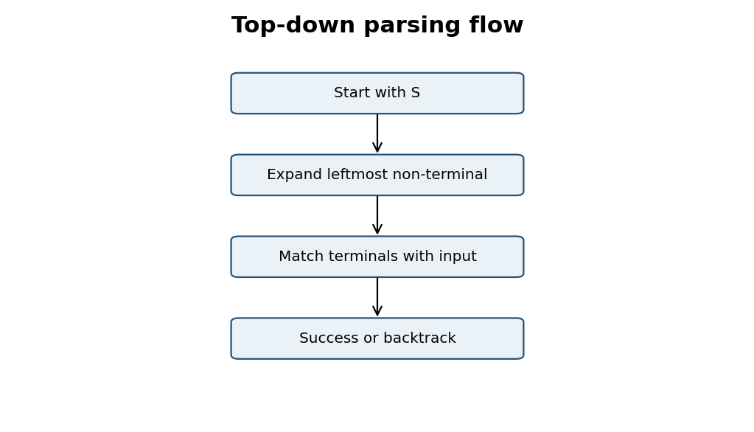

6.2 Trace: The student checks the timetable.
Step | Goal / stack | Action
1 | S | Expand S → DECL
2 | DECL | Expand DECL → NP VP
3 | NP VP | Expand NP → Det N
4 | Det N VP | Match “The student”
5 | VP | Expand VP → V_TRANS NP
6 | V_TRANS NP | Match “checks”; expand NP
7 | Det N | Match “the timetable”; success

The parser starts with S, expands the sentence and subject phrase, matches the subject words, then expands the VP and matches the verb and object. Since the entire input is consumed, a parse succeeds.

6.3 Left recursion and backtracking
A naïve recursive-descent parser can loop on NP → NP PP because it calls NP again before consuming any input. Rewrite NP → NP PP | Base as NP → Base NP_TAIL and NP_TAIL → PP NP_TAIL | ε. This removes immediate left recursion while preserving repeated PP modifiers, although the resulting tree shape changes.
Repeated parsing of the same span/category from different branches causes redundant work. Memoization or chart parsing stores completed sub-results. Naïve top-down parsing can have exponential worst-case behaviour due to backtracking; the actual cost depends on grammar ambiguity and pruning.
Evidence Expected: Pseudocode, trace, flowchart and analysis of left recursion, backtracking and redundant sub-parses.

TASK 6 – Parsing Cost and Improvements
For a noun phrase with k prepositional phrases, each PP may attach to the NP or to a higher VP. A naïve parser may explore many attachment combinations and repeatedly parse the same spans. The number of candidate structures can grow rapidly as k increases.

Possible improvements
- Eliminate immediate left recursion before applying a recursive-descent parser.
- Use a left-corner filter to combine bottom-up evidence with top-down expectations.
- Use memoization to avoid repeated parsing of identical non-terminal/span pairs.
- Use a chart parser such as Earley when arbitrary CFG rules and left recursion must be supported.
A transformed grammar should preserve the intended language. If the parse-tree structure is changed by left-recursion elimination, a tree-reconstruction step may be needed to restore the original constituent structure for downstream processing.

TASK 7 – Earley Parsing (5 Marks)
Guiding Enquiry: How does Earley parsing use dynamic programming to avoid the failures of simple top-down parsing, and what does its chart contain?
Investigate and interpret
An Earley state has the form [A → α • β, i]. A is the rule’s left-hand side, the dot separates recognised material α from expected material β, and i is the origin position where the constituent began.
Operation | Condition | Action
PREDICTOR | Dot before non-terminal B | Add B productions to current chart set.
SCANNER | Dot before matching terminal | Advance dot and add state to next chart set.
COMPLETER | A state has completed | Advance earlier states waiting for this constituent.

7.1 Worked input
Input: “The student checks the timetable today.” Tokens: 0 The, 1 student, 2 checks, 3 the, 4 timetable, 5 today. Use simplified rules S → NP VP; NP → Det N; VP → V NP AdvP; AdvP → Adv.
S[0]: [S -> • NP VP, 0]
Predict NP -> • Det N; predict Det -> • The
After “The” in S[1]: [Det -> The •, 0]; [NP -> Det • N, 0]
Predict N -> • student
After “student” in S[2]: [NP -> Det N •, 0]; [S -> NP • VP, 0]
Predict VP -> • V NP AdvP; predict V -> • checks
After “checks” in S[3]: [VP -> V • NP AdvP, 2]
Predict NP -> • Det N; scan “the”, then predict N -> • timetable
After “timetable” in S[5]: [NP -> Det N •, 3]; [VP -> V NP • AdvP, 2]
Predict AdvP -> • Adv; scan “today”
S[6]: [AdvP -> Adv •, 5]; [VP -> V NP AdvP •, 2]; [S -> NP VP •, 0]

This is a compact teaching trace. A full implementation should list every state generated by predictor closure, scanner and completer, together with its origin and back-pointers.

7.2 Earley flow
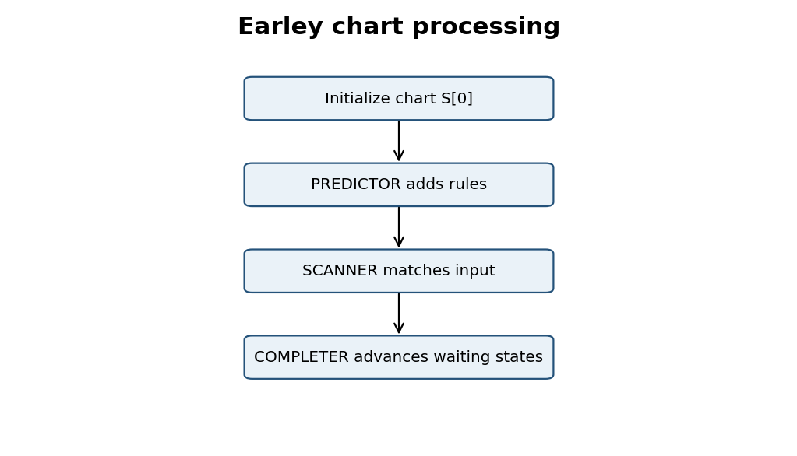
Figure 3. Earley processing cycle. Multiple back-pointers can be stored for one chart item, producing a packed parse forest for ambiguous input.

7.3 Left recursion and complexity
Earley avoids infinite loops by checking whether a state is already present in a chart set. It supports left-recursive CFGs. General worst-case complexity is O(n³) time and commonly O(n²) chart space, with grammar-dependent factors. Unambiguous or constrained grammars often perform better.
Evidence Expected: State definition, Predictor/Scanner/Completer, chart trace, tree recovery and complexity comparison.

TASK 7 – Chart and Parse Recovery
A chart item stores a partial derivation over an input span. Its origin position identifies where the constituent began. Back-pointers record which earlier chart items and grammar rules produced the item. For an ambiguous PP attachment, the same completed category and span can have more than one back-pointer, allowing the parser to represent multiple trees without duplicating all shared structure.
Parser | Advantage | Limitation
Recursive descent | Simple, direct and easy to trace. | Left recursion and repeated backtracking.
Earley | Supports arbitrary CFGs and shares partial results. | Chart bookkeeping and memory cost.

When comparing parsers on the same sentence, count top-down rule expansions/backtracks and Earley chart states. Use identical tokenization and grammar. A measured comparison must be run in the actual implementation; the assignment handout does not provide numerical parser logs.

TASK 8 – Feature Structures and Unification (4 Marks)
Guiding Enquiry: How can attribute–value structures and unification replace multiplied categories to handle agreement and subcategorization?
Investigate and interpret
A feature structure stores grammatical information as attribute–value pairs. It can encode NUM, PER, CASE, AGR and SUBCAT without creating a separate grammar category for every possible combination.

8.1 Lexical feature structures
student: [CAT:N, NUM:SG, PER:3]
they: [CAT:PRON, NUM:PL, PER:3, CASE:NOM]
me: [CAT:PRON, NUM:SG, CASE:ACC]
submits: [CAT:V, AGR:[NUM:SG, PER:3], SUBCAT:<NP>]
send: [CAT:V, SUBCAT:<NP, NP>]
apply: [CAT:V, SUBCAT:<PP>]

A feature path is a sequence of attributes such as VP.SUBCAT or NP.AGR.NUM. Reentrancy means two paths share the same feature structure; for example, subject AGR and finite VP AGR may point to the same value.

8.2 Unification
Unification merges compatible feature structures. If two structures specify the same value for a feature, they unify. If they specify conflicting values, unification fails. Subsumption describes a general feature structure that is less specific than a compatible, more informative structure.
Example | Input | Result
Success 1 | NP[NUM=SG] + V[AGR.NUM=SG] | Unified NUM=SG
Success 2 | Pron[CASE=ACC] + object[CASE=ACC] | Unified CASE=ACC
Failure | NP[NUM=PL] + V[AGR.NUM=SG] | FAIL: number conflict

8.3 Feature-constrained rules
S[AGR=x] -> NP[AGR=x] VP[AGR=x]
NP[NUM=n] -> Det[NUM=n] N[NUM=n]
VP -> V[SUBCAT=<NP>] NP
VP -> V[SUBCAT=<NP,NP>] NP NP
VP -> V[SUBCAT=<CP>] CP
WHQ -> WH[CASE=ACC] Aux NP VP[GAP=OBJ]

8.4 Agreement example
In “The student submits the form”, the subject has NUM=SG and PER=3, matching the verb’s AGR values. In “The students submits the form”, the subject has NUM=PL but the verb requires NUM=SG; unification fails and the parse is rejected.
Evidence Expected: Five lexical feature structures, three unifications including one failure, feature-based rules and comparison with category multiplication.

TASK 8 – Integration with Earley Parsing
Feature structures can be attached to Earley states. During COMPLETER, the features of the completed constituent are unified with the features expected by the waiting state. If unification succeeds, the state advances; if it fails, the candidate is discarded. The parser must distinguish chart states with different feature values, which increases state-comparison and memory costs.
Method | Representation | Maintenance
Category multiplication | NP_SG, NP_PL, VP_SG, VP_PL | Many categories and duplicated rules.
Feature structures | NP[NUM=SG], VP[AGR.NUM=SG] | Fewer general rules; explicit constraints.

Feature structures therefore reduce grammar duplication but do not make parsing free. The implementation must define how feature variables are copied, shared and unified, and must avoid mutating shared structures in a way that corrupts other parse alternatives.

TASK 9 – Probabilistic Context-Free Grammars (5 Marks)
Guiding Enquiry: When a query has several valid parses, how can probabilities select the most plausible one?
Investigate and interpret
A PCFG assigns a conditional probability to each rule A → β. For every left-hand-side category A, probabilities of all its alternative rules must sum to one. The probability of a parse tree is the product of probabilities of the rules used in that tree.

9.1 Normalization example
VP -> V_TRANS NP [0.60]
VP -> V_INTR [0.15]
VP -> V_PP PP [0.15]
VP -> V_SCOMP CP [0.10]
Sum = 1.00

9.2 Maximum-likelihood estimation
The maximum-likelihood estimate is P(A → β | A) = Count(A → β) / Σγ Count(A → γ). Suppose a small illustrative treebank has 20 VP expansions: 12 transitive, 3 intransitive, 3 PP-complement and 2 sentential-complement. These are example counts, not counts from an annotated corpus supplied with the PDF.
VP rule | Count | Probability
VP → V_TRANS NP | 12 | 12/20 = 0.60
VP → V_INTR | 3 | 3/20 = 0.15
VP → V_PP PP | 3 | 3/20 = 0.15
VP → V_SCOMP CP | 2 | 2/20 = 0.10
Total | 20 | 1.00

Unseen rules have zero probability under unsmoothed MLE. Additive or other smoothing reserves probability mass for unseen alternatives. State the smoothing method and parameter, and apply them consistently.

9.3 Ambiguous parse ranking
For “Show the students with the late fee notice”, one parse attaches the PP to VP and another attaches it to NP. Compute each complete tree probability by multiplying all rule probabilities in the tree. The Viterbi parse is the tree with the highest probability. The sentence probability is the sum over all distinct parse trees, not the maximum.

9.4 CKY / Viterbi pseudocode
Initialize chart[i,i+1] with lexical categories.
For span length = 2 ... n:
for each span (i,j) and split k:
for each binary rule A -> B C:
score = P(A -> B C) * chart[i,k][B] * chart[k,j][C]
retain highest score and its back-pointer
Return best S spanning the complete input.

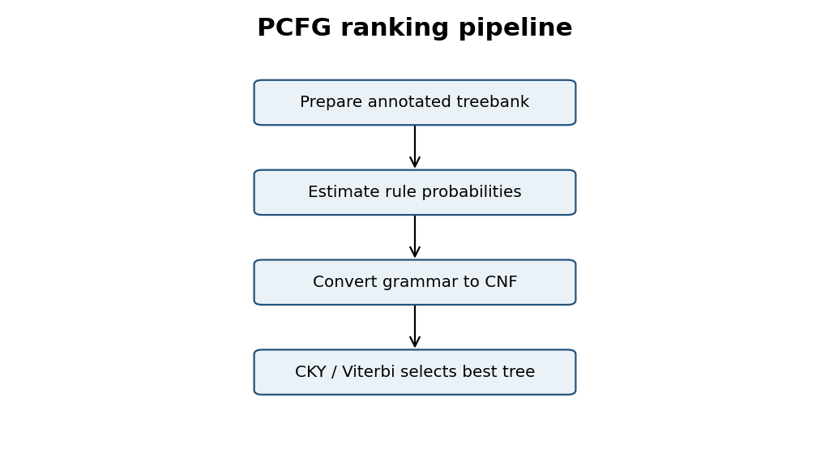
Evidence Expected: Normalized PCFG, MLE counts/formula, tree ranking, CKY pseudocode, CNF conversion and limitations.

TASK 9 – CNF Conversion and Limitations

9.5 CNF conversion example
Original rule: VP -> V NP PP
Introduce helper symbol X:
VP -> V X
X -> NP PP

A lexical pre-terminal introduces a terminal:
Det -> "the"; N -> "student"; V -> "checks".

CKY uses binary productions and lexical productions. Unary and epsilon rules require suitable handling during conversion. The transformation must preserve the language and probability mass; probabilities for introduced helper rules should be assigned consistently.

9.6 PCFG assumptions and failure cases
- Context-freeness: rule probabilities depend on the parent category, not the full surrounding context.
- Position invariance: the same rule probability is used wherever the category occurs.
- Tree preference: multiplying many probabilities can favour shorter derivations unless the model and training data compensate.
- Limited lexical sensitivity: a basic PCFG may not capture that particular verbs strongly prefer specific nouns or prepositions.
A larger, representative treebank improves probability estimates. Lexicalized or neural parsers can capture richer contextual preferences, but they require more data and computational resources. A PCFG remains useful as an interpretable baseline for a controlled helpdesk domain.

TASK 10 – Implement and Test the Parsers (3 Marks)
Guiding Enquiry: Can a working implementation reproduce the behaviour derived by hand?
Investigate and interpret
Implement the grammar and parsers in Python, using NLTK or a custom parser. Use the same tokenized test set for each parser to make comparisons fair.

10.1 Implementation steps
- Define CFG productions and a helpdesk lexicon.
- Prepare at least 30 sentences, including all required sentence types and at least five ambiguous examples.
- Add feature checks for agreement, pronoun case and subcategorization.
- Run a top-down parser and record expansions/backtracks.
- Run Earley and record chart states.
- Estimate PCFG probabilities from at least 20 annotated trees.
- Convert to CNF and run Viterbi CKY.
- Record parse success, parse count, states and runtime.

10.2 Python reference skeleton
import nltk
from nltk import CFG
from nltk.parse import RecursiveDescentParser, EarleyChartParser

grammar = CFG.fromstring('''
S -> NP VP
NP -> Det N
VP -> V NP
Det -> "the"
N -> "student" | "timetable"
V -> "checks"
''')
sentence = "the student checks the timetable".split()
td = RecursiveDescentParser(grammar)
earley = EarleyChartParser(grammar)
print("Top-down:", len(list(td.parse(sentence))))
print("Earley:", len(list(earley.parse(sentence))))

This is a minimal runnable parser demonstration. Expand the grammar before testing the full helpdesk dataset. Feature-aware parsing and PCFG/Viterbi parsing require additional implementation or NLTK feature/PCFG facilities.

10.3 Test set coverage
Group | Minimum examples | Example
Declaratives | 6 | The student checks the timetable.
Imperatives | 4 | Submit the form.
Yes/no questions | 4 | Does the student need a room?
Wh-questions | 4 | When will the exams begin?
Ambiguous attachment | 5 | Book the room near the library for the seminar.
Agreement negatives | 4 | The students submits the form.
Long / embedded | 3 | Tell me when the postponed exams will be held.

Evidence Expected: Working documented code, reproducible tests, comparable tables and at least one plot using actual measured data.

TASK 10 – Results and Reproducibility
Parser | Parse found? | No. parses | States / steps | Runtime (ms)
Top-down | Measure | Measure | Measure | Measure
Earley | Measure | Measure | Measure | Measure
PCFG / Viterbi | Measure | Best parse + score | Chart cells / updates | Measure

Do not report invented timings as measured results. Run the same test set on the same computer, Python version and grammar. Repeat runs and report median runtime. Plot sentence length against chart states after collecting actual measurements.
The assignment handout requires implementation results but does not provide a reference machine or benchmark data. Therefore, the table above is a reporting template rather than fabricated experimental evidence.

TASK 11 – Compare, Recommend and Defend the Parsing Design (2 Marks)
Guiding Enquiry: Which grammar-and-parser combination should be deployed, and what evidence supports the choice?
Investigate and interpret
Criterion | Top-down | Earley | PCFG / Viterbi
Coverage | Limited by grammar; left recursion needs care. | Supports arbitrary CFGs. | Ranks parses licensed by PCFG.
Ambiguity | May backtrack over alternatives. | Shares chart states. | Selects highest-probability tree.
Cost | Can be high with repeated backtracking. | Worst-case O(n³) time, O(n²) space. | CKY O(n³) for binary grammar.
Maintenance | Simple for small grammars. | Works with CFG extensions. | Requires annotated data and updates.
Interpretability | Rule choices are traceable. | Chart states are inspectable. | Scores explain ranking.

11.1 Recommended architecture
Recommend a feature-based CFG + Earley parser + PCFG ranking. Features enforce agreement, pronoun case and verb valence. Earley provides chart-based search and handles left recursion. PCFG scores rank multiple valid parses. A partial-parse fallback handles unsupported or incomplete input.

11.2 Effort and cost
Manual effort includes writing and reviewing 40+ grammar rules, compiling the 60+ word lexicon, preparing 30 test sentences, annotating at least 20 trees and double-checking ambiguous parses. A statistical approach becomes more economical when representative data is available and the cost of adding and maintaining hand-written rules exceeds the cost of collecting and validating annotations.
Evidence Expected: Comparison across coverage, ambiguity, cost and maintenance, with a defended deployment recommendation.

TASK 11 – Recommendation Summary
- Use feature-based rules for explicit agreement and subcategorization.
- Use Earley parsing to avoid the main weaknesses of naïve recursive descent.
- Use PCFG probabilities to rank valid alternatives, not to replace grammatical constraints.
- Use partial parsing and human escalation for unsupported noisy input.
The fastest parser alone is not necessarily the best. The recommended combination balances coverage, interpretability and ambiguity handling. Final accuracy and runtime claims must be supported by the measured results from Task 10.

TASK 12 – Re-evaluate and Adapt the Design (Day-4 Design Challenge) (8 Marks)
Guiding Enquiry: How should the grammar and parser change when messages become conversational, multi-clause and partly ungrammatical?
Investigate and interpret
The changed requirement introduces embedded questions, relative clauses, coordinated clauses, fragments, missing punctuation and conversational fillers. At least 20% of incoming messages may contain a construction outside the original grammar. A strict all-or-nothing CFG is insufficient as the only processing component.

12A. Impact analysis (2 Marks)
New phenomenon | Original gap | Likely effect
Embedded questions | Incomplete CP / gap rules | Clause boundary failure.
Multi-clause coordination | Limited scope rules | More attachment alternatives.
Ellipsis / fragments | Grammar expects complete S | No complete parse.
Missing punctuation | Segmentation relies on punctuation | Longer input and ambiguity.
Conversational fillers | Lexicon lacks discourse markers | Out-of-vocabulary tokens.

Example: “Hi, can you tell me when the exams that were postponed will be held, and also whether the hostel fee is due?” This contains a greeting, matrix question, embedded wh-clause, relative clause and coordinated embedded question.

12B. Evaluate original design (2 Marks)
- “Can you tell me when the exams that were postponed will be held?” requires an embedded wh-clause and a relative clause.
- “Hi, hostel fee due tomorrow?” contains a greeting and elliptical fragment; a strict S → NP VP grammar may reject it.
- “I need the timetable and tell me whether the room is available.” coordinates different clause types.
The original grammar may fail on an unknown greeting, an embedded clause not covered by CP rules, or a fragment. Chart size and parsing time can increase with sentence length and ambiguity. Exact state counts and runtime must be measured using the extended test set; they cannot be inferred from the assignment handout.

12C. Adaptation or redesign (2 Marks)
Decision: MODIFY the existing architecture. Retain the feature-based CFG, Earley parser and PCFG ranking for well-formed domain sentences, while adding robust preprocessing and a partial-parse fallback.
Figure 4. Modified architecture for conversational helpdesk messages.
Evidence Expected: Impact analysis, three new messages evaluated, adaptation plan and evidence-based defence.

TASK 12 – Design Defence

12D. Evidence-based defence (2 Marks)
Decision | Coverage | Cost / effort | Conclusion
Retain unchanged | Low for new constructions | Low short-term; high failure cost | Not recommended.
Modify | Improves coverage and reuses core components | Moderate grammar and annotation effort | Recommended.
Redesign | Potentially broad coverage | High migration and training effort | Unnecessary unless evidence requires it.

Modification is preferred because the original components remain useful for controlled queries, while the new requirements can be addressed through added grammar rules and fallback processing. Retaining the original design unchanged would fail on the expected out-of-grammar input. A complete redesign would discard useful rules and require greater migration effort.

Remaining limitations
- PCFG probabilities depend on treebank size and domain match.
- Feature grammars still require manual linguistic coverage.
- Partial parsing may not recover every long-distance dependency.
- Noisy speech transcripts may need an ASR correction layer.

CONCLUSION
This assignment designed a controlled CFG for university helpdesk queries and showed how phrase-structure rules generate sentences and parse trees. Agreement and subcategorization improve grammaticality. Top-down parsing provides a simple baseline, while Earley parsing uses a chart to handle left recursion and share partial results. Feature structures reduce category multiplication, and PCFG probabilities rank ambiguous parse trees.
The recommended solution is a feature-based CFG with Earley parsing and PCFG ranking, supplemented by partial parsing for noisy or incomplete messages. The Day-4 challenge supports modifying rather than retaining or completely replacing the architecture. Actual parser measurements and treebank probabilities must be generated from the final implementation before they are reported as experimental findings.

REFERENCES
- Jurafsky, D. and Martin, J. H., Speech and Language Processing, chapters on CFGs, parsing and probabilistic parsing.
- Hopcroft, J. E., Motwani, R. and Ullman, J. D., Introduction to Automata Theory, Languages, and Computation.
- NLTK Documentation, parsing and grammar modules: https://www.nltk.org/
- DSA03 Natural Language Processing, Assignment 3 – CO3, supplied course handout.

APPENDIX A – SAMPLE HELP DESK QUERY SET
No. | Sample query | Type
1 | The student checks the timetable. | Helpdesk query
2 | The students submit the forms. | Helpdesk query
3 | The faculty needs a room. | Helpdesk query
4 | The library is open today. | Helpdesk query
5 | Submit the application form. | Helpdesk query
6 | Check the examination schedule. | Helpdesk query
7 | Book the seminar hall. | Helpdesk query
8 | Send me the fee receipt. | Helpdesk query
9 | Does the student need a hostel room? | Helpdesk query
10 | Are the results available? | Helpdesk query
11 | Can I check my placement status? | Helpdesk query
12 | Will the examination begin on Monday? | Helpdesk query
13 | Who submitted the form? | Helpdesk query
14 | What did the student submit? | Helpdesk query
15 | When will the exams begin? | Helpdesk query
16 | Where is the library? | Helpdesk query
17 | Show the students with the late fee notice. | Helpdesk query
18 | Book the room near the library for the seminar. | Helpdesk query
19 | The student with the receipt visited the office. | Helpdesk query
20 | Tell me that the fee is paid. | Helpdesk query
21 | Tell me whether the hostel is available. | Helpdesk query
22 | The exams that were postponed will be held tomorrow. | Helpdesk query
23 | The officer sent me the receipt. | Helpdesk query
24 | Apply for a hostel room today. | Helpdesk query
25 | The portal crashed yesterday. | Helpdesk query
26 | The librarian checked the book and the timetable. | Helpdesk query
27 | These forms are ready. | Helpdesk query
28 | The students submits the form. | Negative / agreement
29 | These form is ready. | Negative / agreement
30 | The officer sent the receipt to I. | Negative / agreement

APPENDIX B – REQUIREMENT CHECKLIST
Assignment requirement | Where addressed
CFG with 40+ rules and 60+ word lexicon | Task 1
30 query sentences and 5 ambiguous examples | Appendix A and Tasks 1–2
Agreement and 5+ subcategorization frames | Tasks 4, 5 and 8
Derivations and ambiguous parse trees | Task 2
Top-down pseudocode and trace | Task 6
Earley chart operations and trace | Task 7
Feature structures and unification | Task 8
PCFG, MLE and CKY | Task 9
Implementation and measurements | Task 10
Comparison and recommendation | Task 11
Day-4 design challenge | Task 12

Submission reminder: the assignment brief asks for five full derivations and trees, complete Earley chart entries, an annotated mini-treebank, and measured implementation results. The document provides worked examples and a consistent answer format. Expand the corpus-specific traces and replace all measurement placeholders with actual outputs before submitting.

